**Curriculum Vitae**

Name: **Dr. Arun kumar gaur**

*M.D. (Radiodiagnosis)*

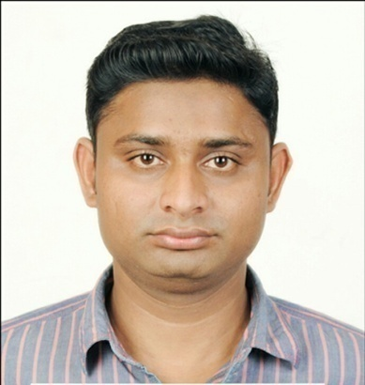

***PERSONEL DETAILS:***

Date of Birth: 25/10/1985

Father’s Name: Mr. Shyamvir Singh

Mother’s Name: Smt. Rajkumari

Contact No. : +918141824816

E-mail i.d.: drakgaur06@gmail.com

Permanent Address: H.no6a/3, shantinagar, bhoor,

Distt – Bulandshahar 203001 (Uttar Pradesh)

***EDUCATIONAL QUALIFICATION:***

|  |  |  |  |  |
| --- | --- | --- | --- | --- |
| Degree | Institute | University | Year of Passing | Aggregate % |
| M.B.B.S. | G.S.V.M Medical College Kanpur | C.S.J.M University Kanpur | 2011 | 64% |
| M.D. (Radiodiagnosis) | Govt. Medical College Bhavnagar | MaharajaKrishnakumarsinhji Bhavnagar University | 2016 | 56 % |

***RESEARCH AND PUBLICATIONS:***

1. E-paper presentation at 69th Annual Conference of Indian Radiological & Imaging Association-21 to 24 January 2016, Bhubaneshwar on the topic “A case of SYNOVIAL

SARCOMA of lower extremity with Lung metastasis”

1. E-paper presentation at 69th Annual Conference of Indian Radiological & Imaging Association-21 to 24 January 2016, Bhubaneshwar on the topic “ A case of NSAID induced Renal Papillary Necrosis”
2. Paper on Klippel-Trénaunay-Weber syndrome: A Case Report in NJIRM.
3. Dissertation on “COLOUR DOPPLER EVALUATION OF CAROTID ARTERIES IN ISCHEMIC STROKE PATIENTS”.
4. Case report on “Imaging and Clinical relevance of Intrahepatic Gall bladder – A Rare Anomaly”: Journal of Gastrointestinal and Digestive System.
5. Pediatric Hip Imaging – An Overview – JIMSA January-march 2017 vol.30 no.1 p.no.70-71.
6. Common respiratory tract infections in Indian Children – Varied Clinical Radiological Presentation- JIMSA January-march 2017 vol.30 no.1 p.no.64-65.

***TRAINING EXPERIENCES:***

1. CME on GI imaging -25 august 2013 B.J.medical college and civil hospital Ahmedabad
2. CME on “IMAGING UPDATE” – 12 January 2014 GMC Bhavnagar
3. CME on Head and Neck Radiology-14 December 2014 B.J.medical college Ahmedabad
4. Good Clinical Practice Workshop-15 December 2014 GMC Bhavnagar
5. CME on RADIOIMAGING UPDATE -12 July 2015 M.P.S.G.medical college Jamnagar
6. CME organized by Indian Federation of Ultrasound in Medicine & Biology-19 July 2015, Mehsana.
7. IRIA Annual State Conference –Gujrat-26&27 December 2015 Ahmedabad
8. 69th Annual Conference of Indian Radiological & Imaging Association-21 to 24 January 2016, Bhubaneshwar
9. Rohilkhand Radiology Update -2016,”MUSCULOSKELETAL AND WOMEN’S IMAGING”, 4 December 2016, Rohilkhand medical college & hospital, Bareilly.
10. 16th NANAVATI MRI Teaching Course 31 March to 02 April 2017, Mumbai.

***WORKING EXPERIENCE:***

1. 3 Years Residency experience as post graduate from august 2013 to august 2016 at Sir T. Hospital & Govt. Medical College, Bhavnagar.
2. Working as senior resident in Teerthanker Mahaveer University, Medical College & hospital Moradabad (U.P.) since September 2016.

***SKILLS AND SPECIALITY:***

1. Conventional radiography (X-ray reporting,IVP,barium procedures,HSG )
2. Sonography with colour Doppler
3. USG guided procedures
4. CT and MRI