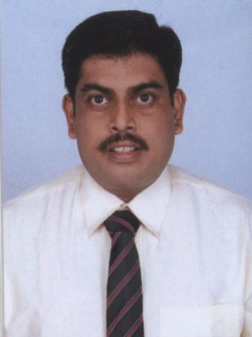**SANDEEP KUMAR DAS**

**Residential Address**

Villa - 57, Mahima City Ville,

Murlipura (Near VIT Campus),

Jagatpura, Jaipur,

Rajasthan - 303012

Ph No. 7837884246, 7837884252, 0141-2988490

Email add: [das.sandeep19@yahoo.com](mailto:das.sandeep19@yahoo.com)

**B Com, MBA- HR, Certificate in** **Entrepreneurship Development & Small Business Management, Admin Executive, Hospital Administrator.**

**Seeking challenging opportunities in / Human Resource / Administration / Marketing with a reputed organization**

* ***HR Management***
* ***Marketing Management***
* ***Front Office Management & Administration***
* ***Hospital Administration***

**PROFESSIONAL EXPERIENCE**

* **The Indian Air force as Senior Non Commissioned Officer 1992- Retired from Indian Air force on 30th April 2018. (26 years of service)**
* **Admin Executive in Pearless Hospital Kolkata.**

Personal details

Full Name Sandeep Kumar Das

Father’s Name Tarani Kumar Das

Date of Birth 03 May 1973

Sex Male

Nationality Indian

Languages Known English, Hindi & Bengali

Work Experience 06 Years administration

Highest Degree MBA- HR

Hobbies Playing chess, Certificate issued by Air Force Station Dinjan, award winner of annual sports meet during year 2006**.**

Educational Qualification:

* **Xth** CBSE Board, Year of passing 1988.
* **XIIth** CBSE Board, Year of passing 1990.
* **B Com** Osmania University, Year of passing 1996.
* **MBA-HR** Sikkim Manipal University, Year of passing 2011, % of marks - 71.38%.
* **Entrepreneurship Development & Small Business Management Course** -Certificate from jointly by the EDI institute Kolkata, GOI, MOD and Netaji Subhash Open University Kolkata.

Leadership Certificate Course

* **Junior warrant officer leadership course,** certified by Medical Training Centre Air Force Station, Bangalore.

IT Skills

* **Diploma in information technology Computer application** from Barrackpore youth computer training centre (Govt of W.B and excel infocom Pvt Ltd).

Declaration:

I do hereby declare information furnished above is true to the best of my knowledge and belief. By virtue of solder-ship entrusted in me, I pledge to undertake the assigned task unflinchingly and endeavor to complete to the best of my ability.

Place: Jaipur

Date: **(SANDEEP KUMAR DAS)**